MAT Exporter

MAT Exporter was designed to export a MAT database to Micro SD. This document will outline the steps needed for a successful database export and website upload.

Device export steps:

- On device: insert micro-SD and install MAT-Exporter.apk

- Run MAT Exporter on device

- Click the Export button
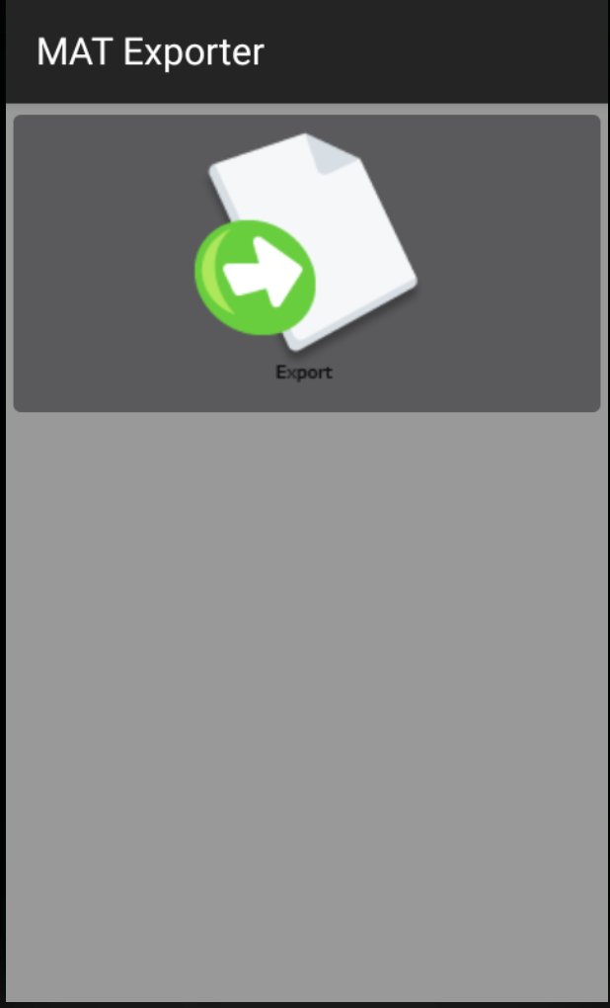

- Wait for code to successfully complete
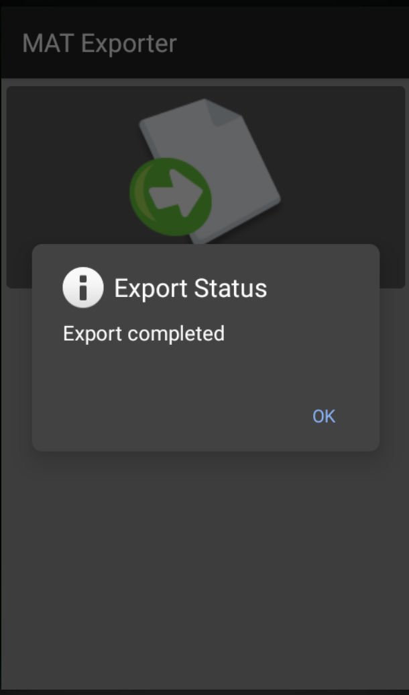

- Remove Micro-SD

Repeat steps 1 – 5 on as many devices as you like.

Website Upload Steps (macOS):

- Connect Micro SD into computer

- Copy data from Android/data/com.mat/files/ to a local directory.

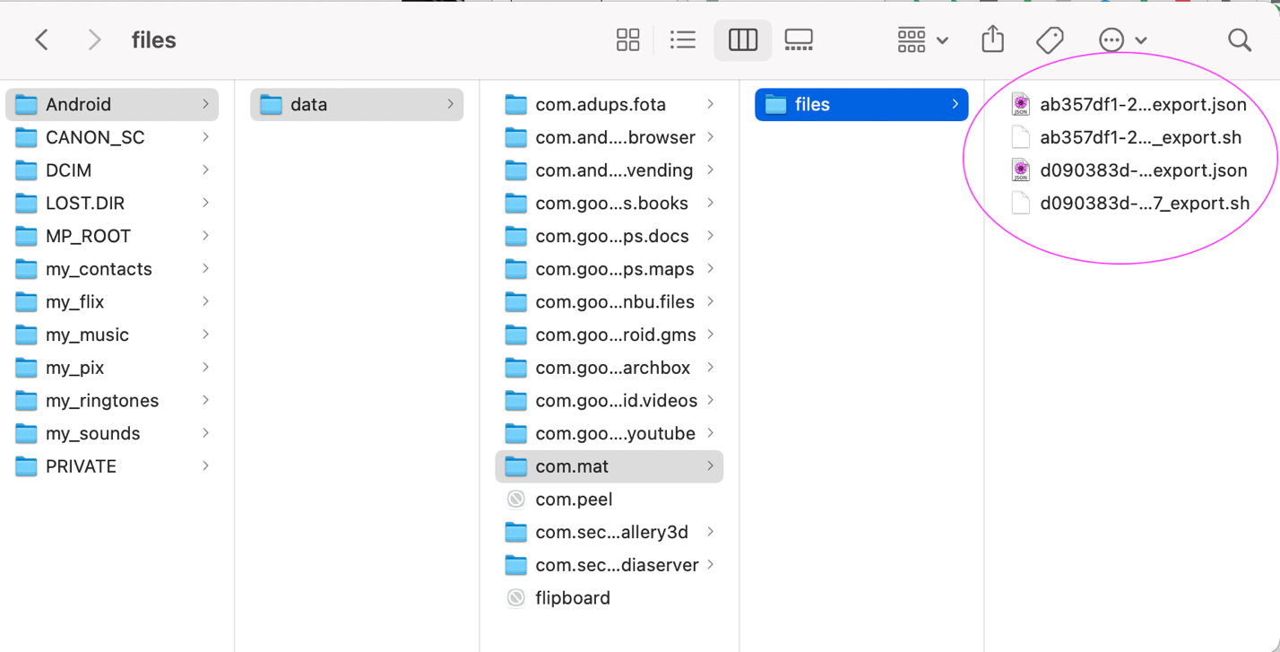
- Open a terminal and navigate to directory from step #2

Open terminal
cd <directory>

- Combine all shell scripts into one

cat *.sh > all.sh

- Make all.sh executable

chmod 777 all.sh

- Run the all.sh script

./all.sh

- Verify data is in hamlab

Navigate to https://harmlabmat.it.ucf.edu
Open study
Verify new responses are added to website

